CURRICULUM VITAE
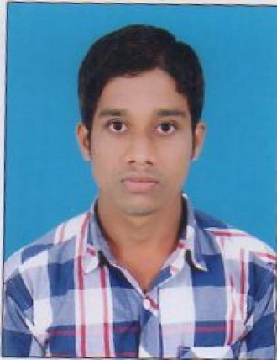

ALOKA MAHANTY
(Work as Business Executive in MEYER PHARMACEUTICAL)

S/o  NILAMBAR MAHANTY
At : KOLATHI GAON,
Po: DASPUR,
Via: BERHAMPUR,
Dist: GANJAM, Cell 9556477649
ODISHA, Pin  760003 Email:alokamahanty95@gmail.com

OBJECTIVE :

Looking for suitable position in an organization, where I will work in challenging environment, which will provide me ample opportunities to learn and grow. If required by the organization I can acquire new skills as quick as possible.
EDUCATIONAL QUALIFICATION :
- MBA (HR,MKT) BPUT,Rourkela
- BSc 1st Class in (Chemistry,Math) from Berhampur University, 2017.
- +2Sc 2nd class in (M,P,C,B) from CHSE Odisha, 2014
- ITI 1st class in ( MECHANIST ) from SCTE&VT Odisha 2012
- 10th 1ST class from HSC Board Odisha, 2010
- PGDCA Grade-A from NISH Berhampur Odisha 2015-16

SKILLS & STRENGTHS :
- Comprehensive problems solving abilities, excellent communication skills and ability to work in a team efficiently.
- Smart, Sincere, Confident, Enthusiastic &
EXPERIENCE:
Work as Marketer In last 6 Month, Business promotion,
Organization : Meyer Organic Pvt Ltd.(Pharma company)

PERSONAL DETAILS :
Name : Aloka Mahanty
Fathers Name : Sri Nilambar Mahanty
Date of Birth : 4th May 1995
Nationality : Indian
Religion : Hindu
Sex : Male
Marital Status : Un-Married
Languages : English, Hindi & Oriya
Hobbies : Traveling, Making friends, etc.

DECLARATION

I hereby declare that the above-furnished particulars are correct to the best of my knowledge and belief.

Place : Berhampur
Date :
(Aloka Mahanty)

